**A**

**Summer Internship Report**

**On**

**"Process Overview of IT Operations"**

(IT346 – Summer Internship - I)

**Prepared by**

Mit Parmar - 21IT104

**Under the Supervision of**

Prof. Rajnik Katriya

**Submitted to**

Charotar University of Science & Technology (CHARUSAT)

for the Partial Fulfillment of the Requirements for the

Degree of Bachelor of Technology (B.Tech.)

for Semester 5

**Submitted at**



**Accredited with Grade A by NAAC**

**Accredited with Grade A by KCG**



**SMT. KUNDANBEN DINSHA PATEL DEPARTMENT OF INFORMATION TECHNOLOGY**

**(NBA Accredited)**

**Chandubhai S. Patel Institute of Technology (CSPIT)**

**Faculty of Technology & Engineering (FTE), CHARUSAT**

**At: Changa, Dist: Anand, Pin: 388421.**

**July, 2022**



**Accredited with Grade A by NAAC**

**Accredited with Grade A by KCG**

**CERTIFICATE**

This is to certify that the report entitled “Process overview of IT operations” is a bonafied work carried out by **Mit Parmar (21IT104)** under the guidance and supervision of **Prof. Rajnik Katriya** & **Mr. Manoj Nair** for the subject **Summer Internship – I (IT346)** of 5th Semester of Bachelor of Technology in **Department of Information Technology** at Chandubhai S. Patel Institute of Technology (CSPIT), Faculty of Technology & Engineering (FTE) – CHARUSAT, Gujarat.

To the best of my knowledge and belief, this work embodies the work of candidate himself has duly been completed, and fulfills the requirement of the ordinance relating to the B.Tech. Degree of the University and is up to the standard in respect of content, presentation and language for being referred by the examiner(s).

|  |  |
| --- | --- |
| Under the supervision of,  Prof. Rajnik Katriya  Assistant Professor  Smt. Kundanben Dinsha Patel Department of Information Technology  CSPIT, FTE, CHARUSAT, Changa, Gujarat | Mr. Manoj Nair  Assistant General Manager  HR & ER  Tata Chemicals Limited  Mithapur, Gujarat - 361345 |
| Dr. Parth Shah  Head of Department (IT)  CHARUSAT, Changa, Gujarat. | |

**Chandubhai S. Patel Institute of Technology (CSPIT)**

**Faculty of Technology & Engineering (FTE), CHARUSAT**

At: Changa, Ta. Petlad, Dist. Anand, Pin: 388421. Gujarat.

**COMPANY CERTIFICATE**

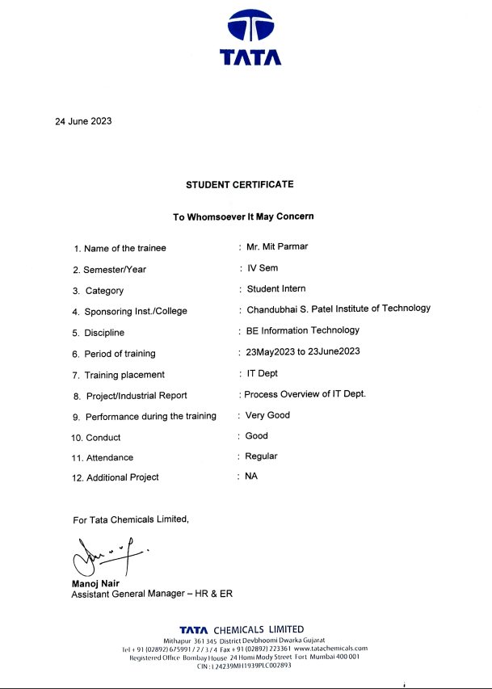

**ACKNOWLEDGEMENT**

I would like to express my deepest gratitude and appreciation to all those who have supported me throughout my internship journey, enabling me to successfully complete this 4 week internship. This accomplishment would not have been possible without the unwavering encouragement, guidance, and mentorship I received from my supervisors, colleagues, and the entire team.

I extend my heartfelt thanks to Mr. Ashok Kanzariya,and Mr. Manoj Nair whose expert advice and constructive feedback played a pivotal role in shaping the direction of this traineeship. Your belief in my abilities and the opportunities provided allowed me to push my limits and achieve remarkable results.

Furthermore, I want to acknowledge the tremendous support I received from my fellow interns and team members. Their camaraderie and willingness to collaborate made the development process smooth and enjoyable.

I am immensely grateful to the entire organization for providing me with this valuable opportunity. The access to cutting-edge technologies and resources, along with the freedom to explore innovative solutions, greatly contributed to the success of this internship.

Lastly, I would like to thank my counselor Prof. Rajnik Katriya and Dr. Parth Shah (Head of Information Technology) for their constant encouragement and understanding during this internship. Their unconditional support empowered me to focus on the task at hand and deliver a product of high quality.

In conclusion, I feel incredibly fortunate to have been part of this enriching experience, where I learn and understand the working of IT operations are performed at scale in I look forward to leveraging the knowledge and skills gained here in my future endeavors.

Sincerely,

Mit Parmar

**ABSTRACT**

One of the reasons I chose this internship opportunity in systems and network administration is my genuine interest in roles such as DevOps (Development and Operations) and SRE (Site Reliability Engineering). These roles combine software development, IT operations, and infrastructure management, which aligns perfectly with my career aspirations and passion for both software development and IT.

I have always been fascinated by the intersection of software development and IT infrastructure. The idea of streamlining and automating software deployment processes, ensuring system reliability, and optimizing performance through efficient infrastructure management excites me. I believe that gaining practical experience in systems and network administration will provide me with a strong foundation and practical exposure to these areas, enhancing my skills and knowledge for pursuing future roles in DevOps, SRE, and similar fields.

Additionally, the dynamic nature of systems and network administration appeals to me. The constant need to adapt to new technologies, solve complex problems, and ensure the smooth functioning of critical systems challenges me intellectually and keeps me motivated. I am eager to explore the intricacies of managing networks, configuring systems, and troubleshooting issues to build a robust and reliable IT infrastructure.

Through this internship, I aim to gain hands-on experience in systems and network administration, expand my technical knowledge, and develop a holistic understanding of IT operations. I am confident that this experience will not only contribute to my personal growth but also provide me with valuable insights and practical skills that will be highly beneficial for my future career in the IT industry.

Aligning with my passion for DevOps and SRE roles, this internship in systems and network administration at Tata Chemicals Limited offers practical experience and skill-building opportunities. The dynamic nature of the field excites me as I look forward to managing networks, configuring systems, and troubleshooting to ensure a robust IT infrastructure. This internship will contribute to my personal growth and equip me with valuable insights and skills for my future career in the IT industry.

**DESCRIPTION OF COMPANY / ORGANIZATION**

Tata Chemicals Limited was founded in 1939, and in 1943, they initiated the establishment of the soda-ash plant. Situated in Mithapur, a town positioned at the far west of Gujarat along the Arabian Sea and the Gulf of Kutch coastline, Tata Chemicals Limited plays a significant role in the development and maintenance of Mithapur. The location of Mithapur is approximately 9 km south of Okha port and 20 km north of Dwarka in Gujarat.

**Products**

Tata Chemicals Limited deals with various chemical products, including Sodium Bicarbonate, Gypsum, Bromine, Caustic Soda, Cement, Hydrochloric Acid, Pure Salt, Liquid Chlorine, Vaccum Iodized Salt, and Soda Ash. In addition to these industrial chemicals, the company also manufactures consumer products such as Edible Salt and Cooking Soda. Tata Chemicals Limited offers a wide range of chemical solutions and consumer goods to meet various industrial and household needs. In conclusion, Tata Chemicals Limited stands as a prominent player in the chemical industry, offering a diverse range of industrial chemicals and consumer products. Through its dedication to quality, sustainability, and corporate social responsibility, the company continues to make significant contributions to both the industrial sector and the well-being of society as a whole.

**Plant Info**

Tata Chemicals Limited possesses an installed capacity of 875,000 per annum, which accounts for approximately 34 percent of the nation's overall capacity. As a leading global producer of synthetic soda ash, it holds a prominent position in the industry. Additionally, Tata Chemicals Limited has been awarded a prestigious 5-star rating by the British Safety Council, highlighting its commitment to maintaining high safety standards.

**Raw Material**

Tata Chemicals Limited utilizes a diverse range of chemical compositions, along with solar-evaporated salts and water sourced from the Arabian Sea, which is approximately 3 kilometers away from the factory premises. Tata Chemicals Limited ensures top-quality chemical products through advanced manufacturing techniques and rigorous quality control. With a diverse range of chemical compositions, the company provides customized solutions for different industries and applications.

**Customer Profile and Market Share**

**Customer Profile**

Tata Chemicals Limited serves a diverse customer base across various industries and sectors. The company caters to both business-to-business (B2B) and business-to-consumer (B2C) customers. Its B2B customers include industries such as glass manufacturing, detergents, pharmaceuticals, food processing, and chemical processing. These customers rely on Tata Chemicals for essential chemical inputs, such as soda ash, caustic soda, chlorine-based products, and sodium bicarbonate, among others. Tata Chemicals also supplies industrial salt, gypsum, and acids to meet the specific needs of these industries.

In the B2C segment, Tata Chemicals has a strong presence in the consumer market. Their consumer products, such as Tata Salt, I-Shakti, Tata Salt Lite, and Tata Salt Flavoritz, are popular choices for households seeking high-quality edible salt. Additionally, Tata Swach, their water purifier brand, offers reliable and affordable water purification solutions to consumers.

**Market Share**

Tata Chemicals Limited holds a significant market share in the chemical industry. With its diversified product portfolio and commitment to quality, the company has established a strong presence both in domestic and international markets. In the soda ash segment, Tata Chemicals is recognized as one of the largest global producers, contributing to a substantial portion of the market. Their reliable supply chain, consistent product quality, and customer-centric approach have contributed to their market leadership.

Furthermore, Tata Chemicals' consumer products, particularly Tata Salt, have gained significant market share in the edible salt segment in India. The brand is widely trusted and preferred by consumers due to its consistent quality and commitment to purity.

**Summary**

Tata Chemicals Limited commands a considerable market share in the chemical industry, serving a diverse range of customers across various sectors. The company's strong presence in both B2B and B2C segments, along with its reputation for quality and reliability, has solidified its position as a key player in the market.

**Table of Contents**

Acknowledgement… i

Abstract. ii

Description of Company/Organization iii

Table of content v

List of figures vi

Chapter 1 Introduction 1

* 1. Training Definition 2

Chapter 2 LAN Cables 3

* 1. What is LAN 4
  2. Various cables used for LAN… 4

Chapter 3 Network Management 6

* 1. Network Management 7
  2. Features 7

**Chapter 4 Securing Data Assets 9**

* 1. Introduction 10
  2. What is firewall. 10
  3. Centralized Data Storage. 11
  4. Magnetic Tape Storage. 11

**Chapter 5 SAP Net Weaver Application Server 14**

* 1. Introduction 15

5.2 Layers in SAP Netweaver Application Server 15

**Chapter 6 Server Room 17**

6.1 Introduction to Server Room 18

**Chapter 7 Helpdesk 21**

7.1 Introduction to Helpdesk 22

**Chapter 8 Conclusion** **24**

8.1 Conclusion 25

**Chapter** **9 References 26**

9.1 References. 27

**List of Figures**

Fig. 2.1 Types of LAN Cables. 15

Fig. 3.1 Flow of Network Management. 8

Fig. 4.1 Firewall 13

Fig. 4.2 Firewall Connectivity 16

Fig. 5.1 Flow of SAP NET Weaver 19

Fig. 6.1 Server Room 23

**CHAPTER – 1: INTRODUCTION**

**1.1 TRAINING DEFINITION:**

Embarking on a journey of professional development, I undertook a compelling internship opportunity in systems and network administration, driven by a genuine interest in roles such as DevOps and SRE. The fusion of software development, IT operations, and infrastructure management resonated deeply with their career aspirations and passion for both realms. This internship served as an avenue to explore and cultivate expertise in the intricate domain of IT infrastructure management, with the aim of preparing the author for future roles in DevOps, SRE, and related fields.

The allure of streamlining and automating software deployment processes, ensuring system reliability, and optimizing performance through efficient infrastructure management was at the core. The dynamic and ever-evolving nature of systems and network administration further enticed them, as they eagerly looked forward to embracing new technologies, solving complex problems, and ensuring the seamless functioning of critical systems. With a determination to gain hands-on experience, expand their technical prowess, and develop a comprehensive understanding of IT operations, the author embarked on this internship journey with the firm belief that it would not only contribute to their personal growth but also equip them with invaluable insights and skills for a thriving future career in the IT industry.

The internship, hosted at Tata Chemicals Limited, offered the ideal platform for my aspirations. The opportunity to actively manage networks, configure systems, and troubleshoot challenges to maintain a robust IT infrastructure was a prospect that ignited their enthusiasm. Embracing this enriching experience, I looked forward acquiring practical knowledge, refining their skillset, and acquiring a holistic understanding of the intricacies involved in IT operations. This, they believed, would be instrumental in shaping their path towards realizing their passion for SRE roles, ultimately paving the way for a successful and fulfilling career in the dynamic IT landscape.

**CHAPTER – 2:** **LAN CABLES**

**2.1 What is a LAN?**

A LAN, short for local area network, is a computer network that connects computers within a specific area, such as homes, universities, offices, and commercial buildings, where computers are in close proximity to each other.

LANs play a crucial role in computer networking, as almost every computer is connected to another device in some way.

The concept of LANs originated in the 1970s when there was a growing need for high-speed connections between computers in universities and laboratories.

The introduction of Ethernet by Xerox in 1973-1974 marked a significant milestone for LAN technology. In 1977, LAN was implemented at the Chase Bank in New York City, demonstrating a major use case for LAN.

**2.2 Various cables used for LAN?**

LAN, being a network of multiple computers and networking hardware, utilizes various types of cables, including:

1. Copper Twisted Pair: Also known as LAN, Ethernet, or Networking cable.
2. Coaxial Cable.
3. Fiber Cable.

Copper Twisted Pair:

The most commonly used cables for connecting computers, routers, switches, printers, gaming systems, PoE devices, and IP cameras are twisted pair copper cables. They come in different categories, such as Cat5e, Cat6, Cat6A, and Cat8.

Cat6 Cables:

Category 6 cable (Cat 6) is a standardized twisted pair cable used for Ethernet and other network physical layers. It is backward compatible with Cat 5/5e and Cat 3 cable standards.

Cat 6 cables have stricter specifications for crosstalk and system noise compared to Cat 5 and Cat 5e. They provide performance up to 250 MHz, whereas Cat 5 and Cat 5e offer up to 100 MHz.

While Cat 6 cable has a maximum length of 55 meters for 10GBASE-T, Cat 6A cable is characterized up to 500 MHz and has improved alien crosstalk characteristics. This allows 10GBASE-T to be used for the same maximum distance of 100 meters as previous Ethernet variants.

Cat 6, an unshielded twisted-pair (UTP) design, was developed as an advancement of Cat 5e. It required more precise manufacturing, resulting in reduced noise and crosstalk for improved performance.

Cat 6 was published by the Telecommunications Industry Association (TIA) in June 2002.

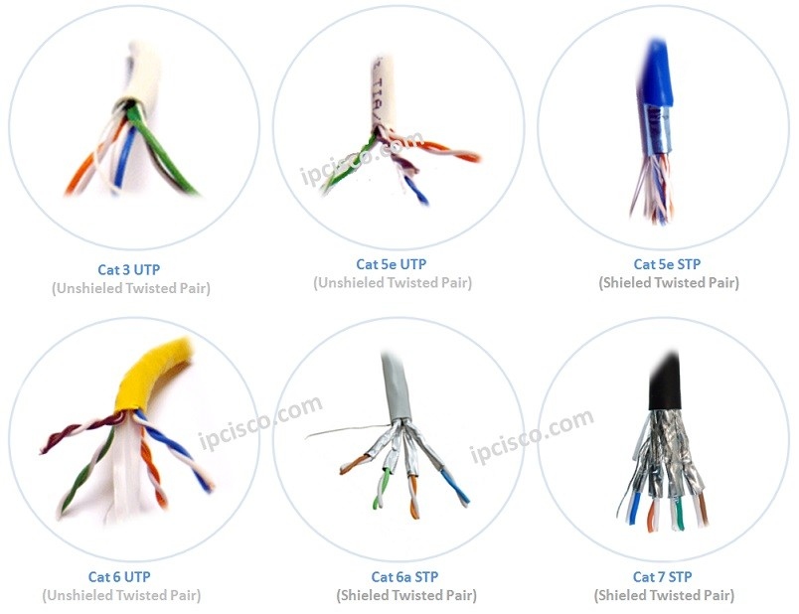

**Figure2.1 Types of LAN Cables**

**CHAPTER – 3: NETWORK MANAGEMENT**

**3.1 Network Management**

Network management is the process of overseeing, controlling, and operating a data network using a network management system. Modern network management systems utilize software and hardware to continuously gather and analyze data, implementing configuration changes to enhance performance, reliability, and security.

Its objectives include configuring and monitoring network components to ensure optimal performance, minimal downtime, proper security, accountability, and flexibility.

**3.1.1Features:**

**- Network Automation:**

One key feature of modern network management systems is network automation. This involves automating the configuration, management, testing, deployment, and operation of physical and virtual devices within a network. Automating everyday network tasks and managing repetitive processes increases network service availability.

**- Network Administration:**

Network administration involves tracking network resources such as switches, routers, and servers. It also encompasses performance monitoring and software updates.

**- Network Operation:**

This entails ensuring the smooth functioning of the network as intended. It involves close monitoring of activities to quickly and effectively address and resolve issues, preferably before users become aware of them.

**- Network Assurance:**

Modern network management systems often include features for network assurance. These features improve network performance, customer experience, and security. Assurance systems leverage network analytics, application analytics, policy analytics, as well as AI and ML technologies to achieve comprehensive network assurance.

**- Network Provisioning:**

Network provisioning involves configuring network resources to support specific services, such as voice functions or accommodating additional users.

**- Network Maintenance:**

Network maintenance covers upgrades and fixes to network resources. It includes proactive and remediation activities conducted in collaboration with network administrators, such as replacing network gear like routers and switches.

**- Network Analytics:**

Network analytics refers to software tools that compare incoming information with preprogrammed operational models and make informed decisions to enhance network performance.

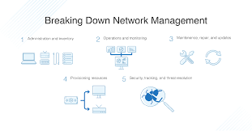

**Figure3.1Flow of Network Management**

**CHAPTER – 4: SECURING DATA ASSETS – APPROACH TOWARDS DATA MANAGEMENT AND PROTECTION**

Given the vast scale and diverse manufacturing units of the company, ensuring robust security measures is of paramount importance. To safeguard its operations and sensitive data, the company maintains an on-premises data center and has recently invested in a firewall solution from Palo Alto Networks.

In addition to maintaining an on-premises data center and implementing Palo Alto Networks' firewall, the company has taken additional measures to bolster its data security. Collaborating with Tata Consultancy Services (TCS), a renowned software and services company under the Tata Group, the company centrally stores its data on TCS servers. This partnership ensures reliable storage infrastructure and leverages TCS's expertise in managing large-scale data environments.

**4.1 What is a Firewall ?**

A firewall is like a security guard for your computer or network. It acts as a barrier between your system and the outside world, such as the internet, to protect you from potential threats.

In technical terms, a firewall is a network security device that monitors and controls the incoming and outgoing traffic on your network. It examines data packets and determines whether they should be allowed to pass through or be blocked based on predefined security rules.

Imagine a security checkpoint at the entrance of a building. The security guard checks everyone's ID and compares it with a list of approved individuals. If your name is on the list, you are granted access. If not, you are denied entry.

Similarly, a firewall checks the "ID" of each data packet that tries to enter or leave your network. It looks at information like the source and destination addresses, the type of data, and the specific rules you've set. If the packet matches the allowed criteria, it's allowed to pass through. If not, it's blocked, keeping potential threats outside.

Firewalls not only protect against unauthorized access but also help prevent malicious activities, such as viruses or hackers trying to break into your system. They act as a shield, filtering out potentially harmful traffic and ensuring that only safe and authorized communication takes place.

**4.2 Centralized Data Storage with TCS:**

To streamline data management and enhance security, the company has opted to centralize its data storage on servers provided by TCS. TCS is known for its robust infrastructure and industry-leading data management capabilities. By leveraging TCS's resources, the company can benefit from secure and scalable storage solutions, ensuring the integrity and accessibility of its critical data.

**Advantages of centralizing data storage for the company**

* **Robust Data Protection:** TCS employs stringent security measures, including encryption, access controls, and backup protocols, to safeguard the company's data against unauthorized access, data breaches, and other potential risks.
* **Scalability and Reliability:** TCS's servers offer scalability, enabling the company to accommodate increasing data volumes as its operations expand. Additionally, TCS ensures high availability and reliability, minimizing the risk of data loss or downtime.
* **Disaster Recovery:** TCS implements comprehensive disaster recovery mechanisms to protect against unforeseen events or system failures. These measures include regular backups, replication across multiple locations, and efficient recovery processes to ensure data integrity and business continuity.

**4.3 Magnetic Tape Storage:**

In addition to centralized data storage with TCS, the company employs magnetic tape storage as a cost-effective solution for archiving and preserving large volumes of data. Magnetic tapes provide secure offline storage that is resistant to cyber threats and unauthorized access.

The company leverages magnetic tape storage for the following purposes:

* **Long-Term Data Archiving:** Magnetic tapes offer a reliable and efficient method for storing historical or infrequently accessed data. This approach helps optimize storage costs and frees up space in the primary data center, while still ensuring data availability when needed.
* **Regulatory Compliance:** Certain industry regulations may require the retention of data for extended periods. Magnetic tape storage allows the company to comply with these regulatory requirements while ensuring the integrity and security of the archived data.

By utilizing both TCS's centralized data storage and magnetic tape technology, the company employs a comprehensive approach to data management and security. This multi-layered strategy ensures redundancy, scalability, and adherence to industry best practices for data protection. Through the collaborative efforts between the company, TCS, and Palo Alto Networks, the company's data security posture is strengthened significantly. The combination of an on-premises data center, Palo Alto Networks' advanced firewall, centralized data storage with TCS, and magnetic tape storage establishes a robust framework for safeguarding sensitive information across the company's extensive network.

By prioritizing data security and adopting a proactive approach, the company demonstrates its commitment to maintaining confidentiality, integrity, and availability of its data assets. These measures not only protect the company's operations but also foster trust among its customers, partners, and stakeholders.

**4.4 Features of the Firewall used:**

* **Intrusion Prevention System (IPS):** The Palo Alto Networks firewall incorporates a powerful Intrusion Prevention System (IPS) that proactively detects and mitigates potential attacks. This feature utilizes sophisticated algorithms and signatures to analyze network traffic in real-time, identifying and blocking malicious activities. By continuously monitoring the network for threats like malware, viruses, and unauthorized access attempts, the IPS enhances the company's security posture, ensuring the integrity and confidentiality of its data assets.
* **Key benefits of the IPS feature:**
  + - Advanced Threat Detection: The IPS employs advanced techniques to identify and block emerging threats that traditional security measures may overlook. It helps the company stay ahead of evolving attack vectors and zero-day vulnerabilities.
    - Real-time Response: By providing real-time threat intelligence, the IPS enables immediate response and remediation, minimizing the potential impact of security incidents and reducing downtime.
    - Automated Protection: The IPS leverages automation to proactively update its threat signatures and adapt to new attack patterns. This automation ensures that the company's network is continuously protected against the latest threats.
* **Application Visibility and Control:** The Palo Alto Networks firewall offers granular visibility into network traffic and enables comprehensive control over application usage. This feature allows administrators to gain insights into the applications being used within the network and enforce policies to regulate their usage effectively.
  + **Key benefits of the Application Visibility and Control feature:**
    - Enhanced Security Policy Management: With detailed visibility into application traffic, administrators can create and enforce granular security policies based on specific applications or application categories. This level of control minimizes the risk of unauthorized or malicious application usage, preventing potential data breaches.
    - Bandwidth Optimization: By monitoring application traffic, the firewall helps identify and manage bandwidth-intensive applications, ensuring that critical applications receive priority access to network resources. This optimization improves network performance and user experience.
* **User Identity Management:** The Palo Alto Networks firewall integrates with authentication systems and enables user-based access controls. This feature associates network activity with individual user identities, allowing administrators to define access policies and enforce restrictions based on user roles and privileges.
  + **Key benefits of the User Identity Management feature:**
    - Granular Access Control: User-based access controls enable administrators to enforce least privilege principles, granting users access only to the resources they require for their roles. This reduces the attack surface and mitigates the risk of unauthorized access to sensitive data.
* **User Activity Monitoring:** By associating network activity with user identities, the firewall facilitates comprehensive auditing and monitoring. It allows administrators to track user behavior, detect anomalies, and investigate security incidents effectively.
* **Virtual Private Network (VPN) Connectivity:** The Palo Alto Networks firewall offers robust VPN connectivity capabilities. This feature allows employees to securely access the company's network resources from remote locations, ensuring data privacy and confidentiality even when working outside the office premises.
  + Key benefits of the VPN Connectivity feature:
    - Secure Remote Access: VPN connectivity establishes encrypted tunnels between remote devices and the company's network, protecting data transmission from eavesdropping and interception. This secure access enables employees to work remotely without compromising the confidentiality of sensitive information.
    - Compliance and Data Privacy: VPNs help organizations meet regulatory compliance requirements by ensuring secure communication and data
    - protection. This feature is particularly important when handling sensitive customer data or adhering to industry-specific regulations.
* **Threat Intelligence and Automation:** The Palo Alto Networks firewall leverages advanced threat intelligence and automation capabilities to proactively identify emerging threats and automatically deploy countermeasures. This feature enables the company to stay ahead of evolving security risks and minimize the potential impact of attacks.
  + Key benefits of the Threat Intelligence and Automation feature:
    - Proactive Threat Detection: The firewall utilizes threat intelligence feeds and machine learning algorithms to identify new and evolving

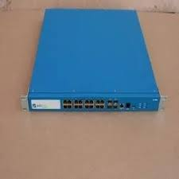

**Figure 4.1 Firewall**

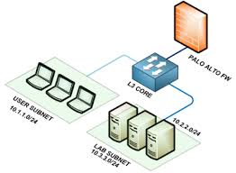

Figure 4..2 Firewall Connectivity

**CHAPTER - 5: SAP NETWEAVER APPLICATION SERVER**

**5.1 SAP NetWeaver Introduction**

SAP NetWeaver Application Server, also referred to as SAP Web Application Server, plays a crucial role as a web application server within the SAP NetWeaver framework. It serves as the foundation for hosting and executing SAP applications, providing a robust platform for managing and delivering web-based solutions.

**5.2 Layers in SAP Net Weaver Server**

The architecture of SAP Web Application Server encompasses five key areas, each serving a distinct purpose and contributing to the overall functionality of the server:

**1. Presentation Layer:**

The presentation layer is responsible for creating the user interface of SAP applications. It offers developers the flexibility to design intuitive interfaces using technologies such as JavaServer Pages (JSP), Business Server Pages (BSP), or Web Dynpro. This layer integrates with the underlying business layer to fetch and display the relevant business content in either Java or ABAP.

**2. Business Layer:**

The business layer constitutes a J2EE (Java 2 Enterprise Edition) certified runtime environment that handles incoming requests from the Internet Communication Manager (ICM) and generates dynamic responses. It is here that the core business logic of SAP applications is implemented. Developers can write the business logic in either ABAP or Java, adhering to the J2EE standards. This layer enables seamless integration with enterprise JavaBeans (EJB) and facilitates access to business objects in the ABAP environment, leveraging their existing business logic and persistence capabilities.

**3. Integration Layer:**

The integration layer includes the local integration engine, an integral part of SAP Web Application Server. It facilitates seamless connectivity and communication with SAP NetWeaver Process Integration (PI), which was previously known as SAP Exchange Infrastructure (XI). The local integration engine provides messaging services for exchanging messages between various components connected through SAP PI. This layer plays a crucial role in enabling seamless integration and data flow across different systems and applications.

**4. Connectivity Layer:**

The connectivity layer is managed by the Internet Communication Manager (ICM), which acts as a central gateway for handling communication between SAP applications and external

systems. The ICM is responsible for routing user interface requests to the appropriate components within the presentation layer. It provides a unified framework for supporting various communication protocols such as Hypertext Transfer Protocol (HTTP), Secure HTTP (HTTPS), Simple Mail Transfer Protocol (SMTP), Simple Object Access Protocol (SOAP), and Fast Common Gateway Interface (FastCGI). This layer ensures secure and reliable communication between SAP applications and external entities.

**5. Persistence Layer:**

The persistence layer within SAP Web Application Server is designed to ensure database independence and efficient transaction handling. It enables SAP applications to interact with databases seamlessly while providing a scalable and reliable transaction management mechanism. The persistence layer supports open standards, allowing developers to write business logic that is independent of the underlying database and operating system. It employs Open SQL for optimized data access within the ABAP environment. Furthermore, it offers support for additional technologies like Java Data Objects (JDO), Container-Managed Persistence (CMP) for EJB, and Java Database Connectivity (JDBC) API for enhanced data access capabilities.

By incorporating these architectural components, the SAP NetWeaver Application Server provides a comprehensive and robust platform for hosting and executing ABAP-based SAP applications. It ensures seamless integration, efficient communication, and reliable data management, enabling organizations to develop and deploy enterprise-grade solutions with ease and efficiency.

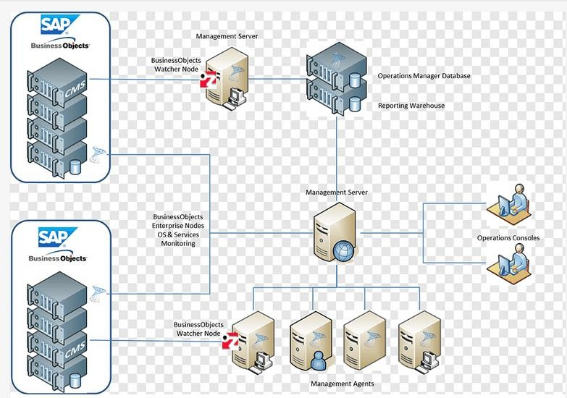

**Figure 15.1 Flow of SAP NET Weaver**

**CHAPTER – 6: SERVER ROOM**

**6.1 Introduction to server room**

A server room is a specialized area within a building or data center that is specifically designed to house computer servers, networking equipment, and other critical infrastructure necessary for the operation of digital systems. It serves as the nerve center of an organization's IT infrastructure, providing a controlled environment that ensures the optimal performance, reliability, and security of the servers and associated equipment.

To understand the intricacies of a server room, let's explore each aspect in greater detail:

Location Considerations: The choice of location for a server room is crucial. It should be situated away from external walls to minimize the risk of water damage in case of pipe bursts or external factors. Exterior windows are best avoided to reduce security vulnerabilities and the potential for breakages. Additionally, locating the server room centrally within the building offers advantages in terms of cable management, as it facilitates the efficient routing of cables to devices in other rooms. If a centralized server room is not feasible, distributed server closets on each floor can be used as an alternative.

Air Conditioning and Climate Control: Maintaining an optimal climate within the server room is essential for the reliable and efficient operation of servers. Servers generate heat, and excessive heat can lead to performance degradation and hardware failures. To address this, server rooms employ specialized air conditioning systems known as "close control air conditioning" or PAC (precision air conditioning). These systems provide precise temperature and humidity regulation within tight tolerances. PAC systems operate continuously, ensuring a stable environment for the servers. They often feature advanced monitoring and control mechanisms, allowing administrators to remotely monitor temperature, humidity levels, and other environmental factors. Alerts can be configured to notify administrators in case of any deviations from predefined thresholds, enabling proactive management of the server room environment.

Fire Protection and Suppression: The potential risk of fire in a server room necessitates robust fire protection measures. The primary goal is to detect fires in their early stages, alert personnel, and suppress the fire while minimizing disruption to operations. Traditional fire suppression agents like Halon gas, which was effective but environmentally harmful, have been largely phased out. Modern server rooms employ alternative solutions such as inert gases (e.g., nitrogen, argon, carbon dioxide) and clean chemical agents like FM200. These substances are effective in extinguishing fires without causing harm to the environment or human safety. Additionally, fire-resistant cable coatings, such as FEP tubing, can be employed to reduce the risk of fire propagation caused by heat generated from data cables and cords.

Redundancy and High Availability: For mission-critical environments, ensuring high availability and minimizing downtime is of utmost importance. Redundancy plays a crucial role in achieving these objectives. Redundancy involves the implementation of duplicate systems and components to eliminate single points of failure and mitigate the impact of common-mode failures. In the context of a server room, redundancy can include redundant power supplies, uninterruptible power supply (UPS) systems, backup generators, and redundant cooling systems. Redundant systems provide failover mechanisms that automatically switch operations to backup components in case of a failure, ensuring seamless continuity of services and minimizing disruptions. The level of redundancy implemented

depends on factors such as the criticality of the systems, the organization's tolerance for interruptions, and the desired level of resilience.

In summary, a server room serves as the backbone of an organization's IT infrastructure, providing a controlled and secure environment for servers and critical equipment. Through careful consideration of location, air conditioning, fire protection, and redundancy, server rooms create an optimal operating environment that ensures reliable and secure data storage, processing, and connectivity. Well-designed and maintained server rooms contribute to data protection, minimize downtime, and support the overall business objectives of an organization.

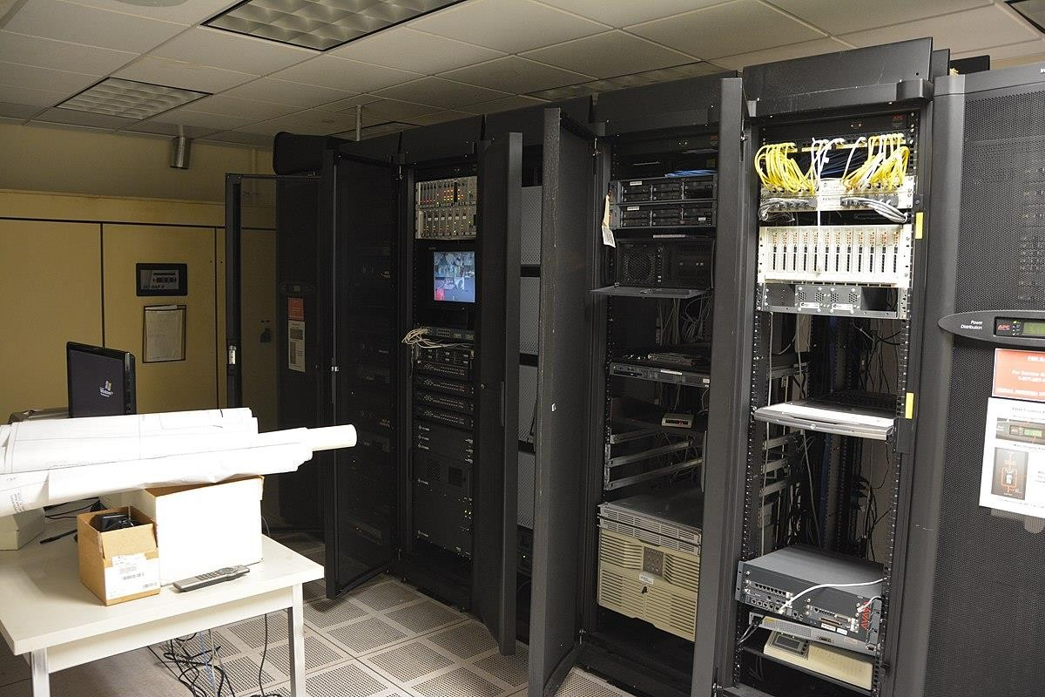

**Figure 6.1Server Room**

**CHAPTER - 7: Helpdesk**

**7.1 Introduction to Help Desk:**

Providing Comprehensive Support and Ensuring Smooth Operations

The help desk is an essential department or individual within an organization responsible for providing comprehensive assistance, support, and information to users facing electronic or computer-related problems.

It serves as a central point of contact for users seeking solutions and guidance, ensuring their smooth experience with technology and maximizing their productivity. The role of the help desk extends beyond reactive troubleshooting, as it holds a unique position that allows frequent communication with users, resulting in valuable insights for planning, development, and improvement within the organization's information technology landscape.

A research conducted in some popular University, emphasized the value derived from an organization's help desk. The study revealed that the help desk's significance lies not only in its ability to provide reactive responses to user issues but also in its regular communication with numerous customers or employees.

Through these interactions, the help desk gains valuable information on technical problems, user preferences, and overall satisfaction levels. This data proves to be instrumental in planning and development efforts across other information technology units, fostering continuous improvement and ensuring alignment with user needs.

Some of the common issues handled by the help desk include:

• Password Resets:

The help desk serves as a crucial resource when users encounter password-related issues. Whether passwords are forgotten, expired, or need to be changed for security purposes, the help desk is there to assist. They guide users through the necessary steps to reset their passwords, ensuring that access to their accounts is regained promptly. By following established protocols and verification procedures, the help desk verifies the identity of the user to maintain data security and prevent unauthorized access. Additionally, they educate users on best practices for creating strong and secure passwords to enhance overall account protection.

• Printer and Peripheral Issues:

Printers, scanners, and other peripherals are integral components of an efficient workplace. However, technical problems with these devices can disrupt workflow and productivity. The help desk is well-versed in troubleshooting and resolving such issues, offering comprehensive support for printer and peripheral-related challenges. They provide guidance on connectivity, ensuring devices are properly connected to the network or computer. In cases where drivers need to be installed or updated, the help desk assists in the process, ensuring compatibility and optimal functionality. They also offer configuration assistance to ensure seamless operation and troubleshoot any hardware or software conflicts that may arise.

• Computer and Application Performance:

When computers or applications experience performance issues such as sluggishness, freezing, or software glitches, the help desk is available to address these concerns. They investigate the root causes of these problems, employing diagnostic tools and techniques to identify underlying issues. By analyzing system logs, monitoring resource utilization, and conducting performance tests, the help desk determines the factors affecting performance. Based on their findings, they provide solutions to optimize system performance, which may include cleaning up unnecessary files, updating software and drivers, or recommending hardware upgrades. Their aim is to enhance user productivity by ensuring smooth and efficient computer and application performance.

• Internet Connectivity:

In today's interconnected world, a stable and reliable internet connection is essential for seamless communication and accessing online resources. The help desk plays a critical role in diagnosing and addressing internet connectivity issues that users may encounter. Whether it's slow speeds, intermittent connections, or complete outages, the help desk collaborates with network administrators or Internet service providers to identify the root causes of these problems. They conduct thorough troubleshooting, including checking network configurations, diagnosing hardware or software conflicts, and verifying physical connections. Through their expertise, they strive to restore and maintain uninterrupted internet access, ensuring users can carry out their tasks effectively.

• IT Security Events:

The help desk assumes a vital role in responding to and managing IT security-related events to safeguard the organization's systems and data. They actively monitor for security breaches, malware infections, phishing attempts, and other cyber threats. In the event of a security incident, the help desk acts swiftly to identify and contain the threat. They collaborate closely with the organization's security team, providing critical information and assisting in the implementation of response plans. This may involve isolating affected systems, performing malware scans, resetting compromised accounts, and implementing additional security measures. By promptly addressing security events, the help desk helps mitigate risks, protect sensitive data, and ensure the continuity of operations.

The help desk goes beyond resolving immediate issues and offers additional services to enhance the overall technology environment within the organization. These services, often integrated into the broader range of options provided by technology partners like Connections for Business, include:

• Security Challenges: Engaging in discussions with users and stakeholders regarding security challenges faced by the organization. The help desk team leverages their expertise and knowledge base to identify potential vulnerabilities, recommend security measures, and implement best practices to safeguard sensitive data and systems.

• Cloud-Based IT Solutions: Assisting with the implementation and management of cloud-based IT solutions. The help desk collaborates with users to understand their requirements, advises on suitable cloud solutions, and facilitates a smooth transition to cloud-based environments, ensuring data accessibility, scalability, and cost-effectiveness.

• Tech Environment Planning and Building: Leveraging their expertise, the help desk team assists in planning and building robust technology environments. They ensure the infrastructure meets the organization's current and future needs, considering factors such as scalability, reliability, and performance. The team helps configure hardware, software, and network components to create a stable and secure technology ecosystem.

• Operational Continuity: Working towards the goal of keeping businesses up and running 24/7, the help desk team focuses on operational continuity

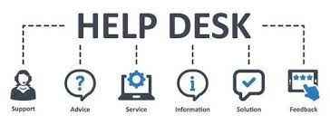

**Figure 7.1 Helpdesk**

**CHAPTER – 8: CONCLUSION**

**8.1 Conclusion:**

In conclusion, my traineeship in network and systems administration has been an invaluable experience that has equipped me with essential skills and knowledge in the field. Throughout my traineeship, I had the opportunity to work on various projects and tasks, gaining practical experience and enhancing my understanding of network infrastructure management.

During my traineeship, I acquired hands-on experience in configuring and troubleshooting network devices such as routers, switches, and firewalls. I learned the importance of maintaining a secure network infrastructure and actively participated in projects related to network security.

Additionally, I had the opportunity to work with virtualized server environments, where I gained practical knowledge of setting up virtual machines and managing storage resources. This experience provided me with a deeper understanding of the benefits of virtualization in optimizing server utilization and streamlining IT operations.

Throughout my traineeship, I collaborated with experienced network and systems administrators who provided mentorship and guidance. Their support has been instrumental in my professional growth and development in the field. I am grateful for the opportunity to work in a dynamic and challenging environment, where I could apply my theoretical knowledge to real-world scenarios.

The traineeship also exposed me to industry-standard methodologies such as ITIL (Information Technology Infrastructure Library) and agile project management. These methodologies emphasized the importance of collaboration, efficiency, and continuous improvement in delivering high-quality IT services.

In conclusion, my network and systems administration traineeship has provided me with valuable insights into network infrastructure management, security, and virtualization. I am confident that the skills and knowledge I have gained during this traineeship will serve as a strong foundation for my future career in the field. I am excited to continue learning and growing as a network and systems administrator, making significant contributions to the industry.

**CHAPTER – 9: REFERENCES**

**9.1 References:**

1. <https://www.paloaltonetworks.com/network-security/next-generation-firewall>
2. <https://www.sap.com/india/products/technology-platform/netweaver.html>’
3. <https://www.tatachemicals.com/about-us/company-profile>